Revit Tutorial

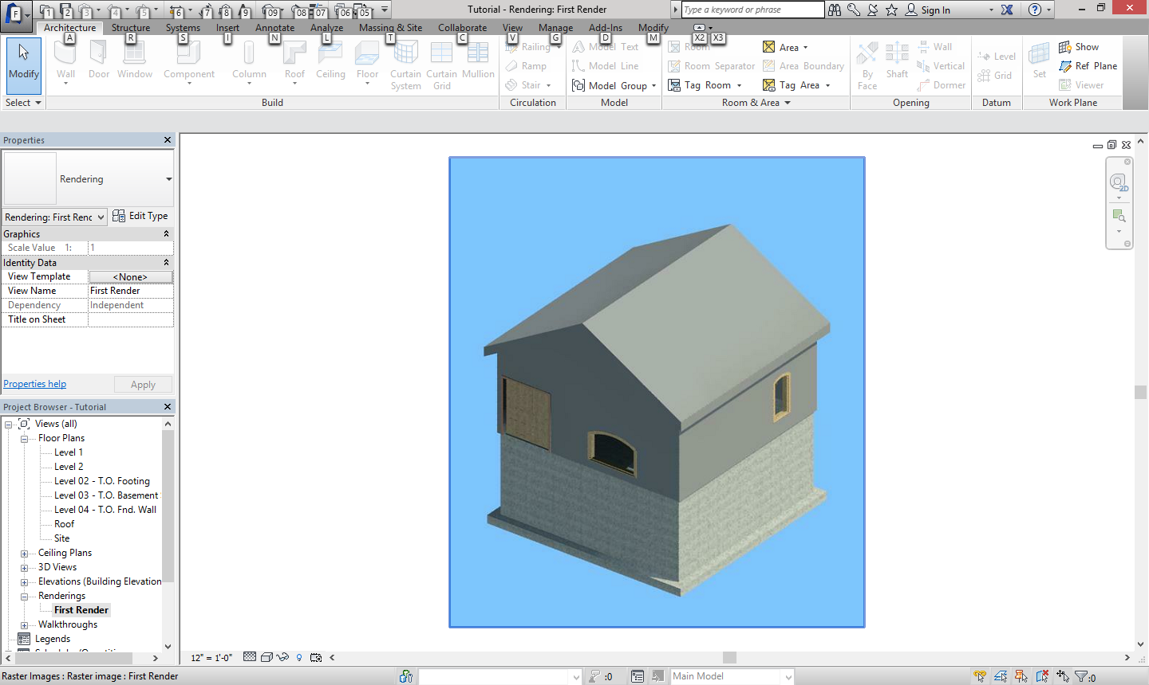

By: Justin Young

1. **Introduction**

In this tutorial you will learn the basics of Revit. The final product of this tutorial will include key features like, a gable roof, concrete foundation with footing, windows and doors, and the ability to load components. You will also get to know the interface of Revit which corresponds with some of the other Autodesk programs.

1. **Prerequisites**
   1. For this Tutorial the only software you will need is Revit. The skill level needed is very easy, (as in never used the program before). As you get towards the end of the tutorial then the skill level gets a little harder but that’s only because the tutorial stops giving basic information like where the wall tool is. For this tutorial the only special skill needed is how to use your computer and how to read.
2. **Skills to Be Learned**
   1. 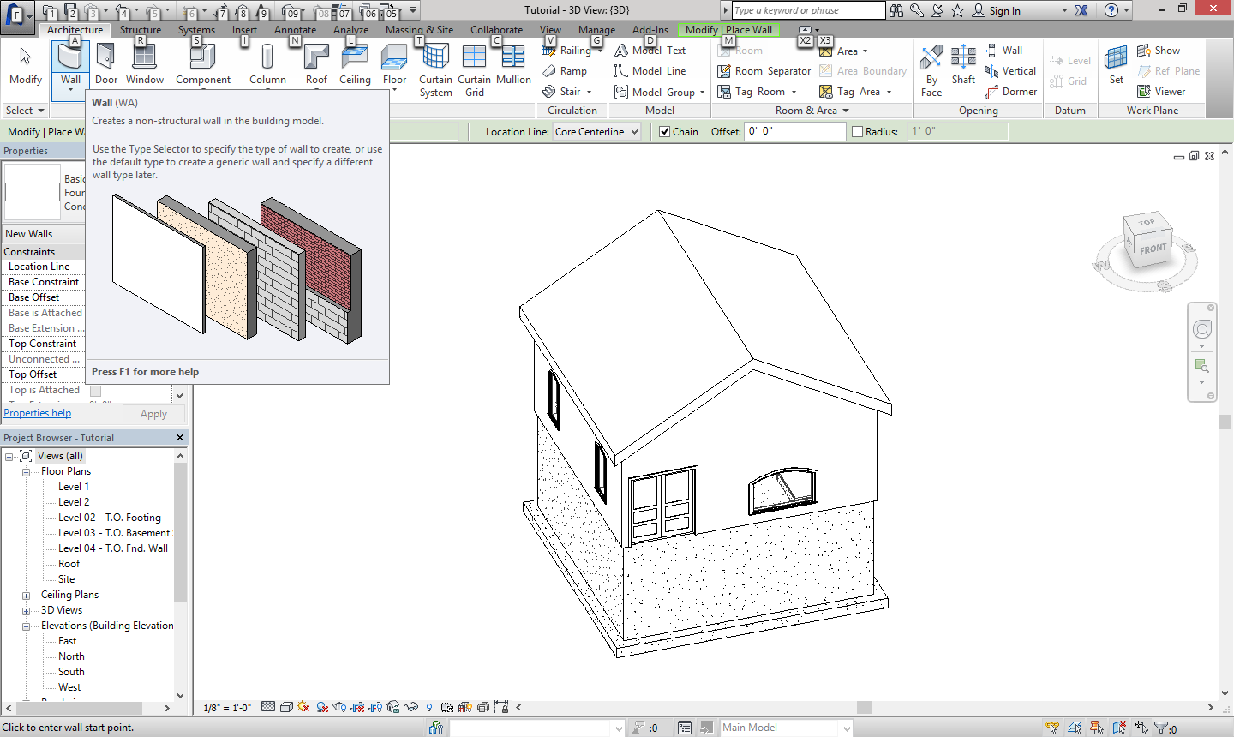In this tutorial you will learn the basics of Revit. These basics include how to, make walls and dimension them, how to make three roofs (Gable, Hip, Single Slope), place components to design your building, create a foundation with a footing, place doors and windows, and create drawings and titleblocks. This will set the learner up to create a building in Revit. It is essential to have these skills or you will not be able to succeed in creating a building.
   2. The first skill to be explained is how to make walls and dimension them. This skill will help you create the base for your structure. You can also change the material of the wall and make it a concrete wall so you can make a foundation. You can also dimension the walls by selecting them, and then click the dimension that makes it permanent.
   3. The second skill is making the three roofs in this tutorial, (Gable, Hip, and Single Slope). You will learn this in the tutorial below.

Before You Start, Here are some hints to help you navigate Revit. Please Refer Back to this when you have a question.

Hints:

* You can’t load doors or window components from the component tab under Architecture. Only when you are under the doors or windows tab.
* You can get to the 3D view by going to the View tab then in the middle of selection bar there is 3D view.
* Not all components are loaded on all computers.
* You can put a render in a titleblock.
* You can view your renderings in the Project Browser under the Renderings folder.

At The bottom of every view there is a Visual styles button. This will allow you to make it so there is Color to your views. I’d recommend “Realistic.”

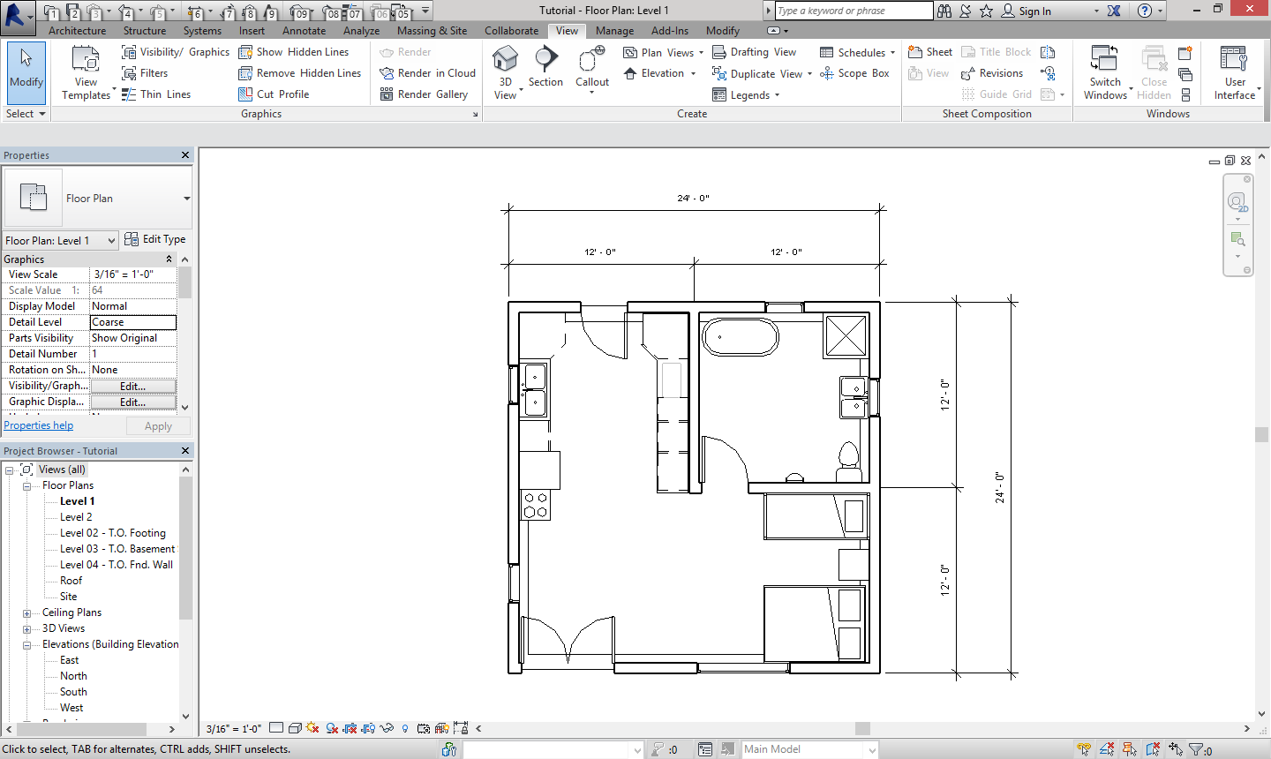

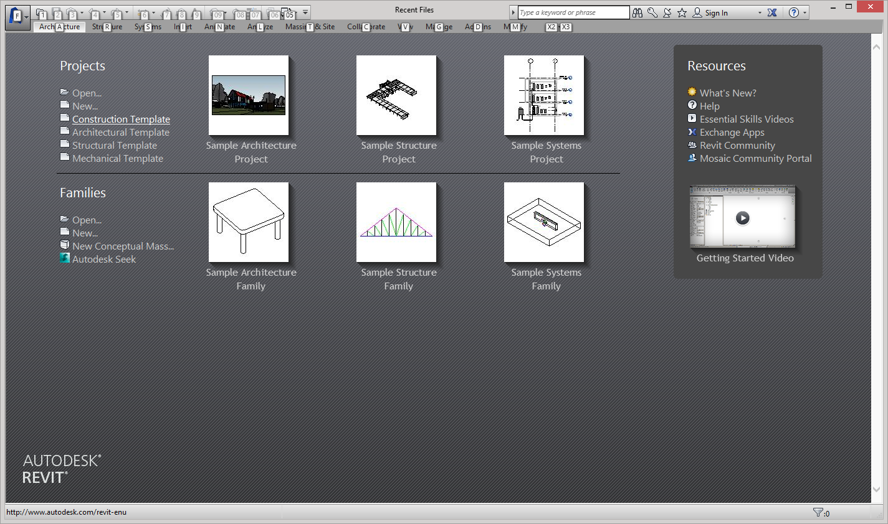

Click on Construction Template to get started.

The First thing you want to do once you open the project is go to an elevation view.

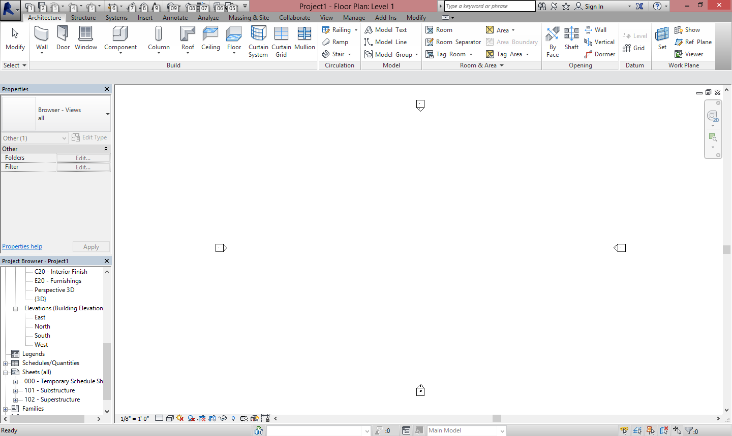

When you get into the elevation delete all the views

You will next need to create three new levels. create them like shown below.

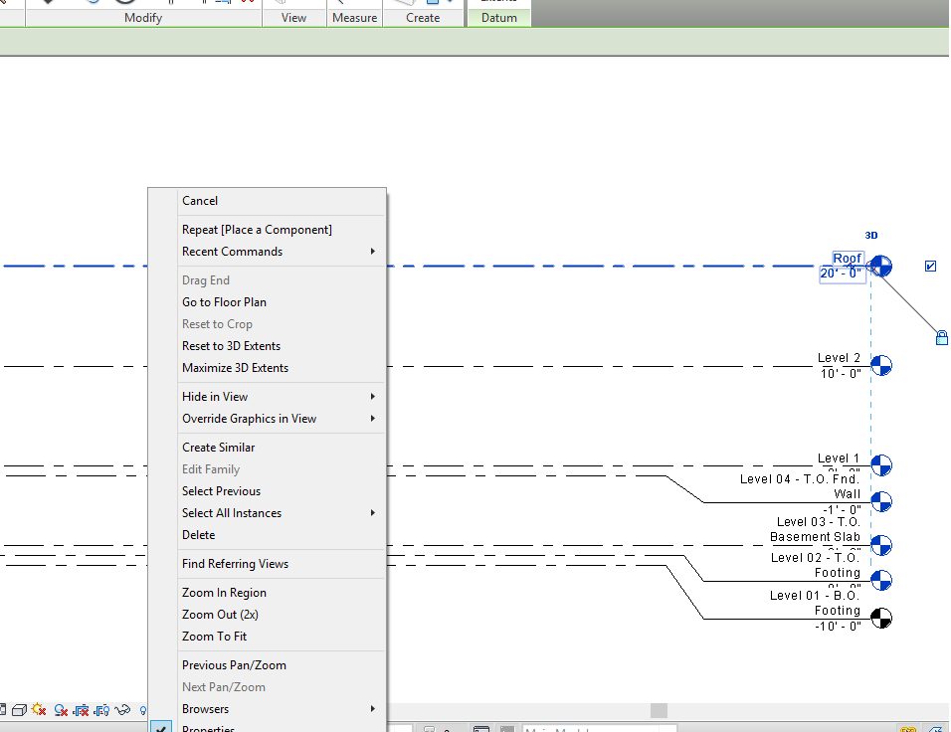 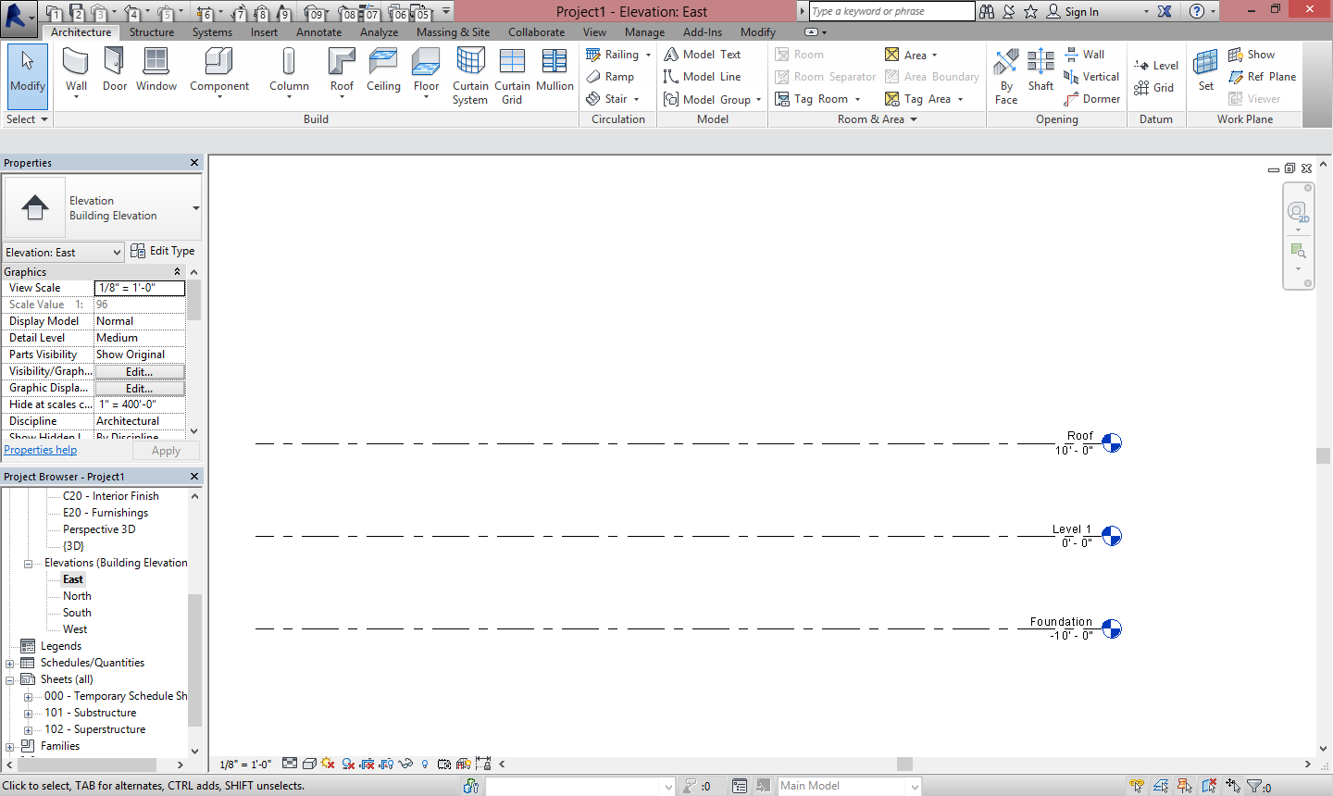

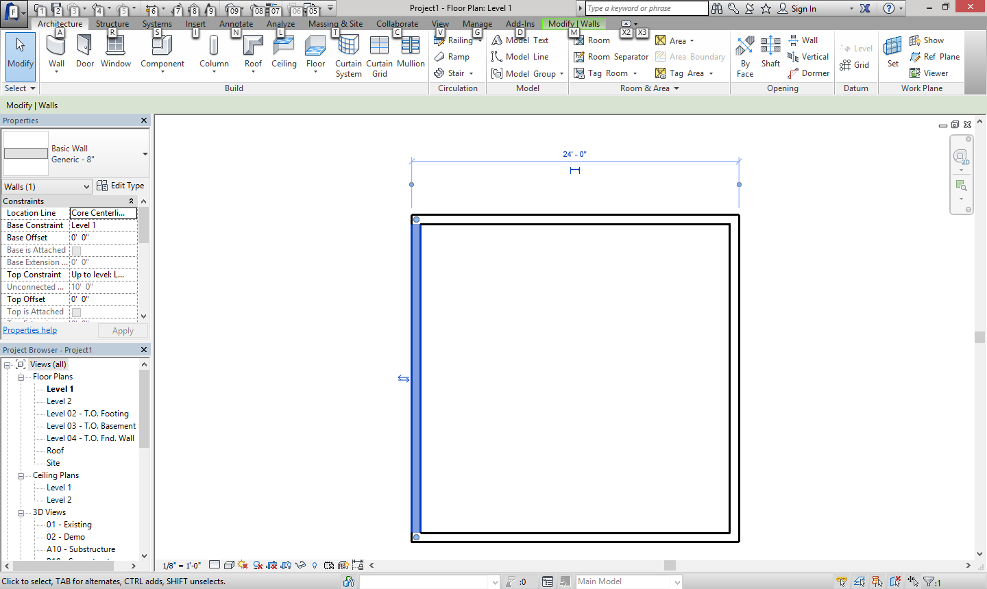

Using the wall tool, created 4 architectural walls that are all 24ft long

Make sure you click on the blue dot so that the dimension is on the outside

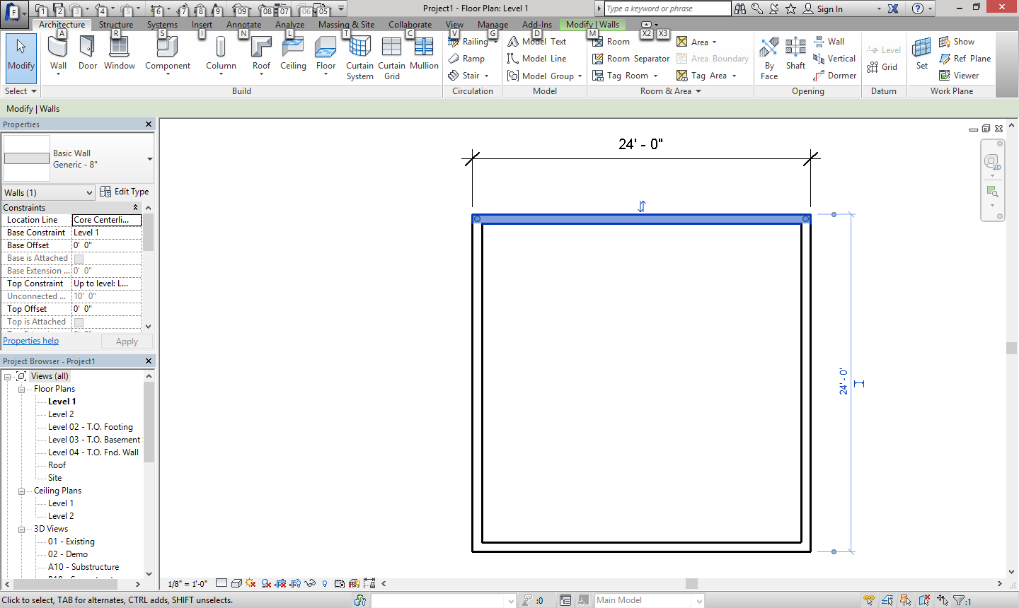

In Revit you can dimension as you build by clicking on a wall then click on the dimension tab which makes it permanent

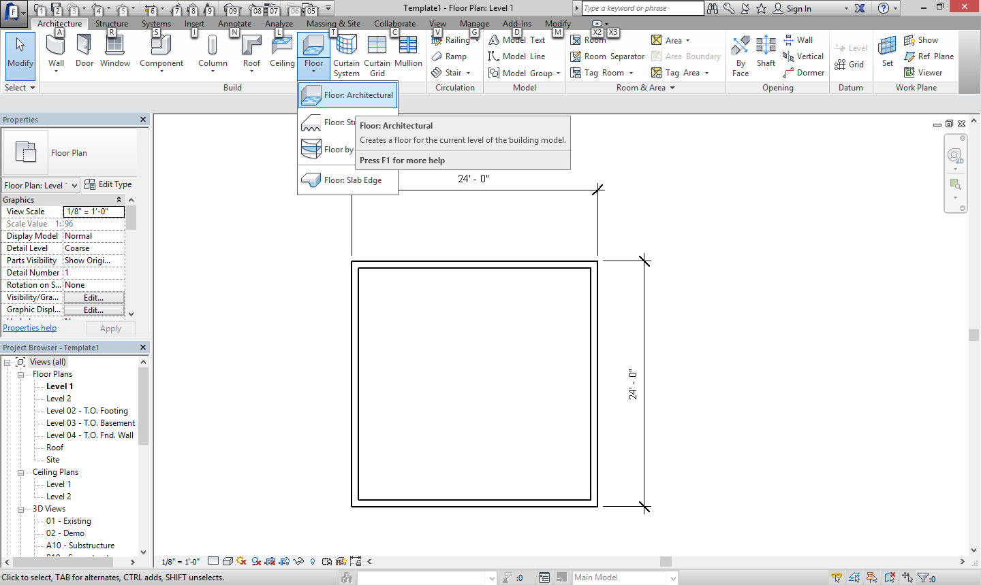

Next we are going to make an architectural floor

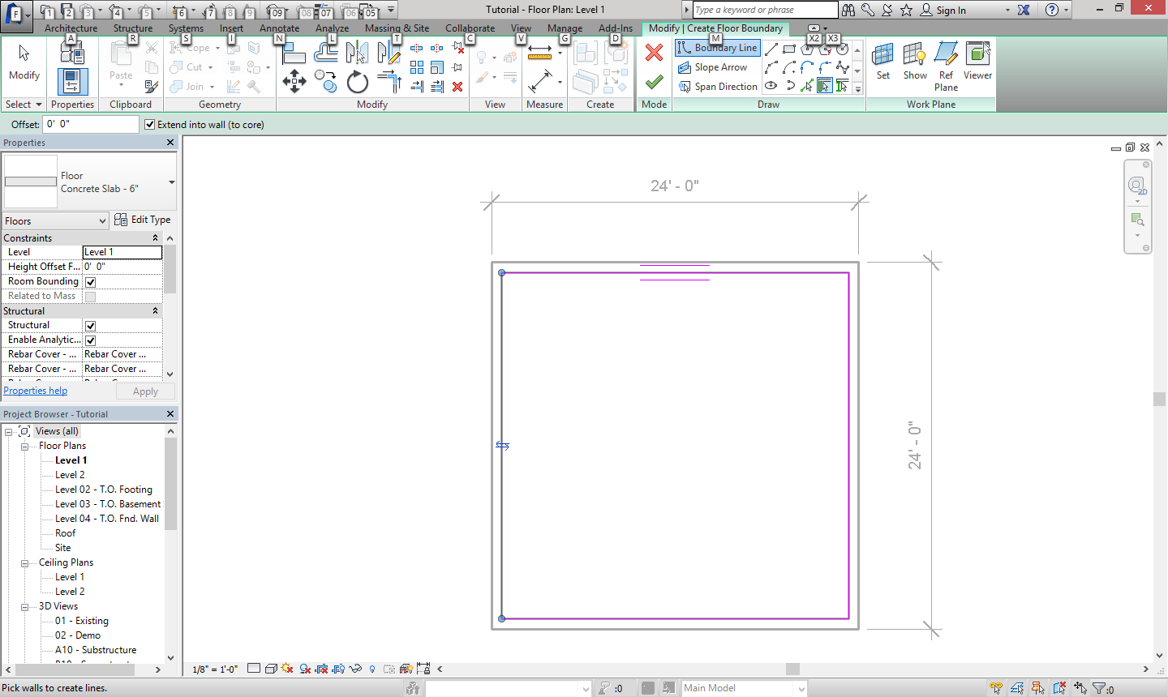

Select the boundary for the floor by clicking on the walls that will in close it. When done click the green check

We are also going to add some interior walls that are from the midpoint and are 12’ long

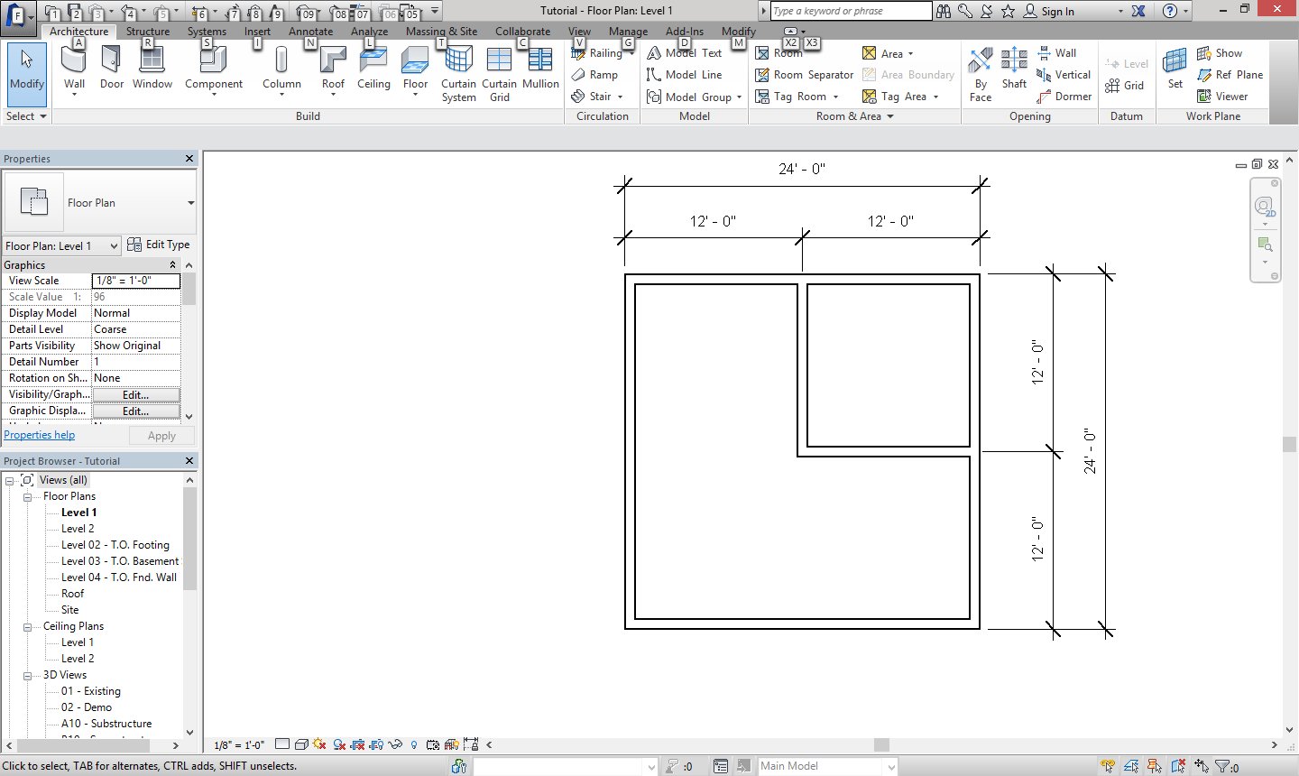

Again make sure the dimension is on the outside.

Now we are going to add door, click on the door tab in Architecture.

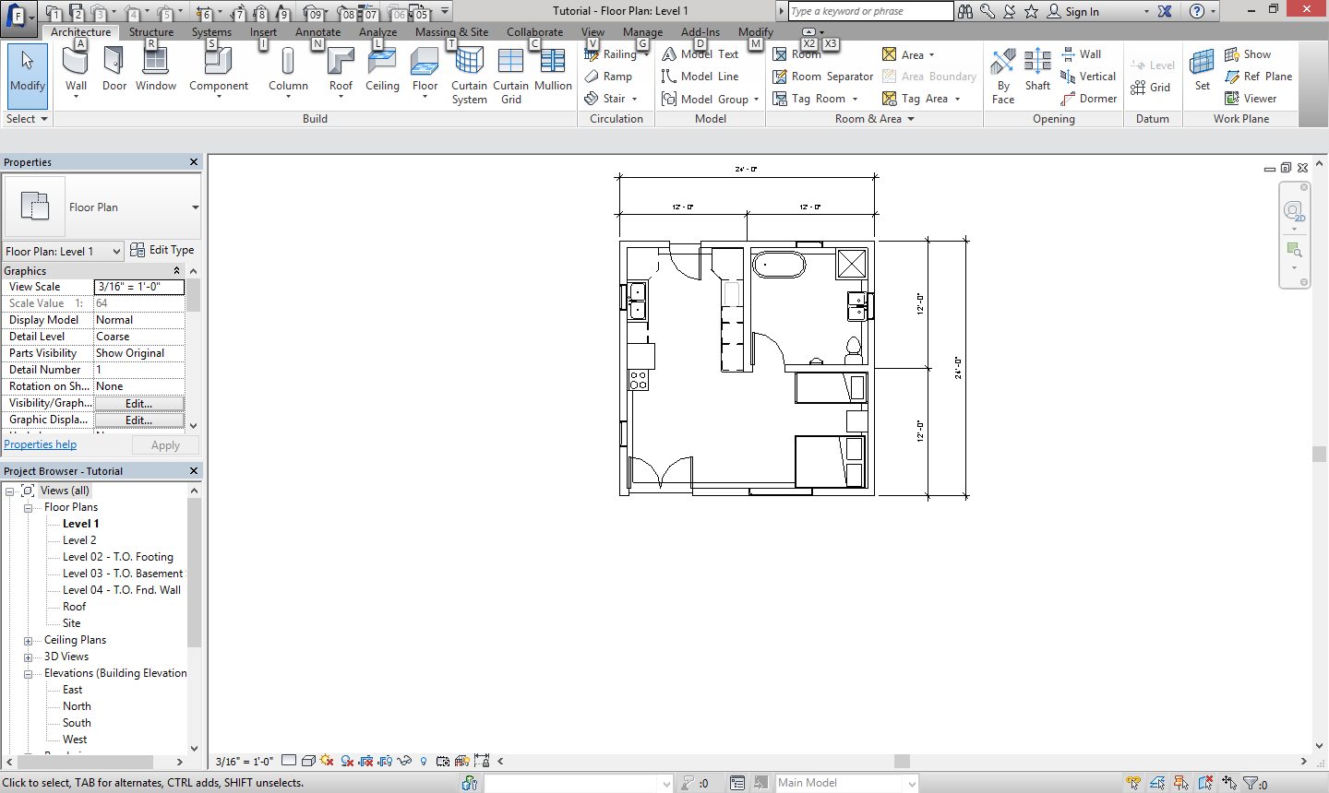

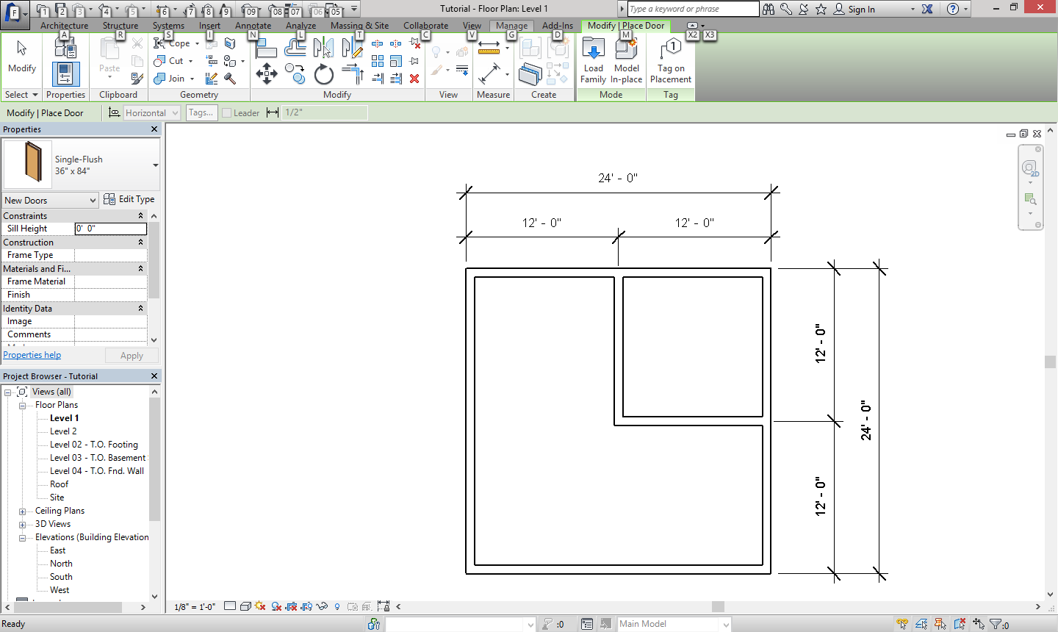

Click on the load family

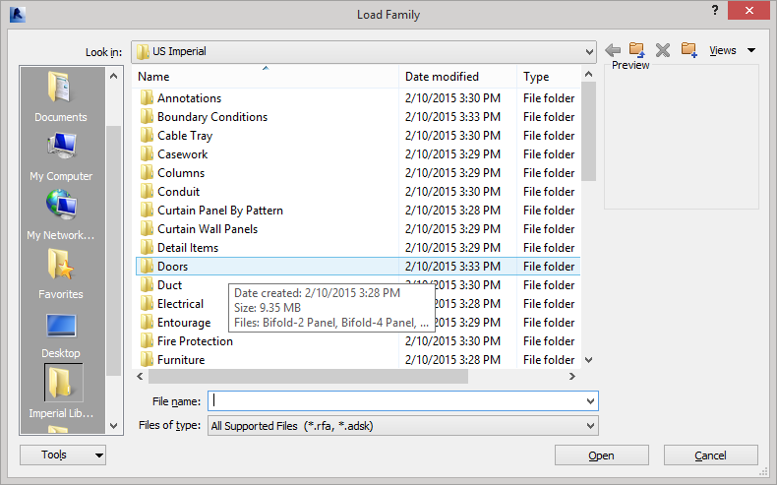

Click on doors, then residential. The door we want will be the top on called Door-Exterior-Full Glass-wood, and open the file. (Revit 2016) Choose the size 72” 84”.

‘

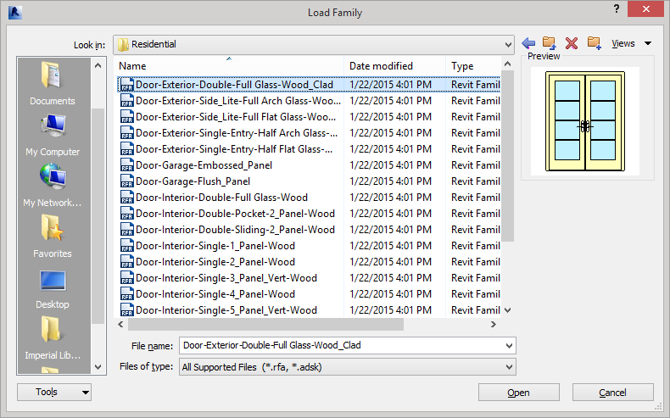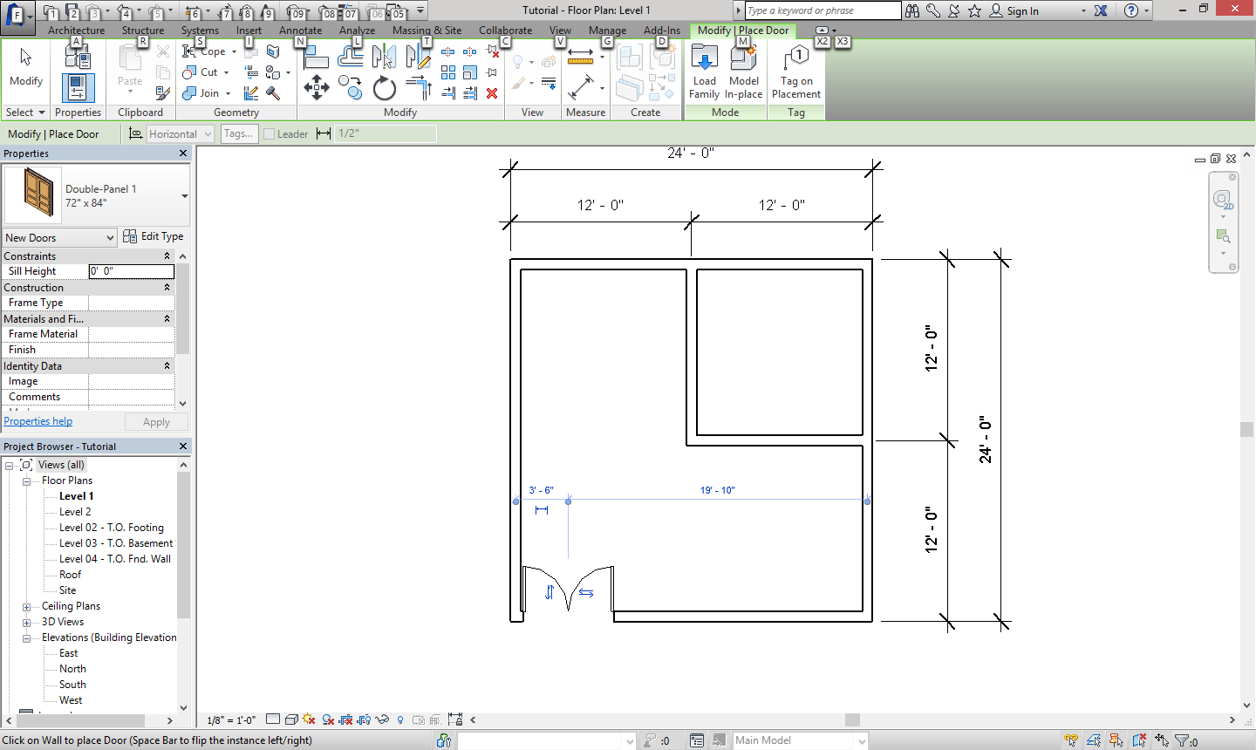

Place the door like shown

We also want to add some regular doors. Select the properties tab then click on single flush, 36” 84”

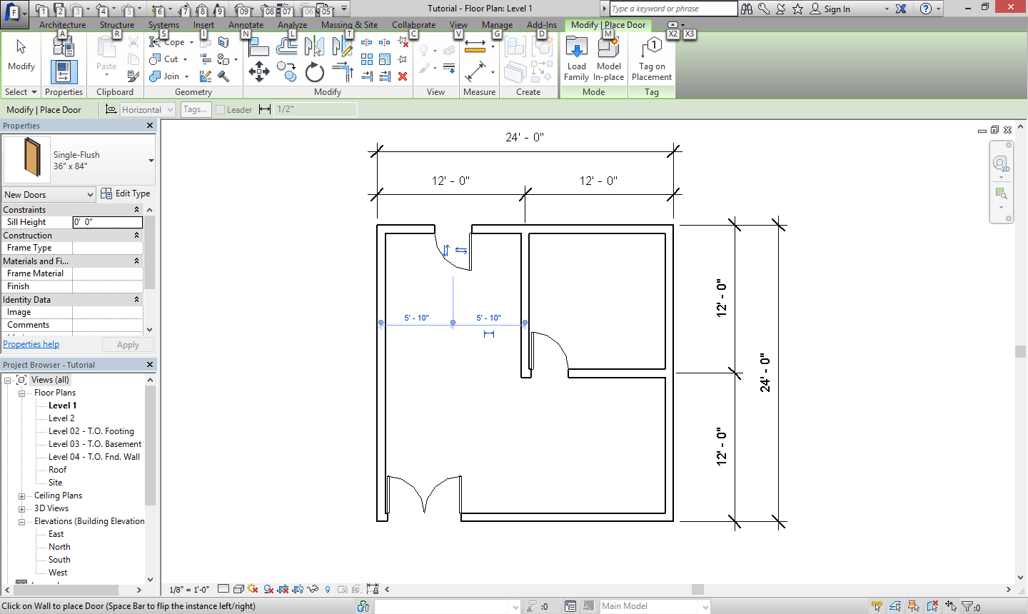

Hint: if the door is backwards, hit the spacebar to switch the side it is on.

Place the doors as shown

This First roof is the hip roof. Go to roof and choose roof by footprint. Make sure the box that says Defines slope is checked. Then we want to select all the exterior walls like shown.

Now we are going to do 3 different types of roofs, Hip, Gable, and a lean to roof (single slope).

We also want a 1’ overhang

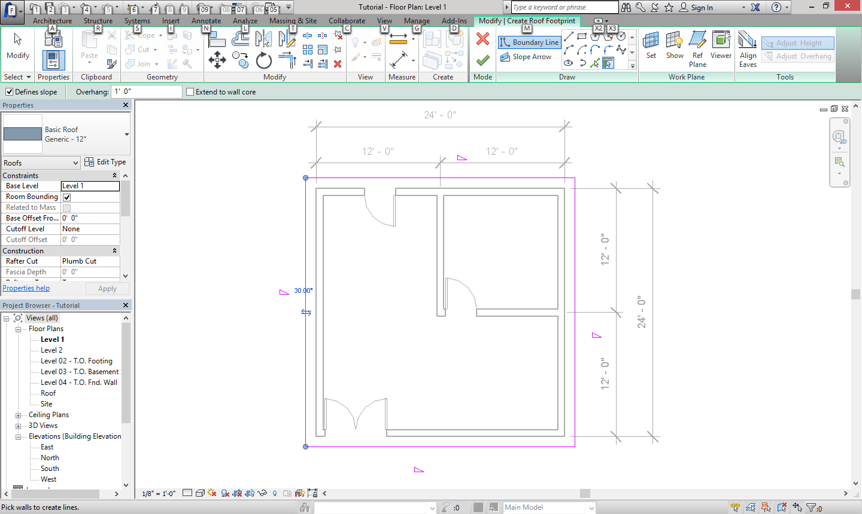

Click the green check when finished

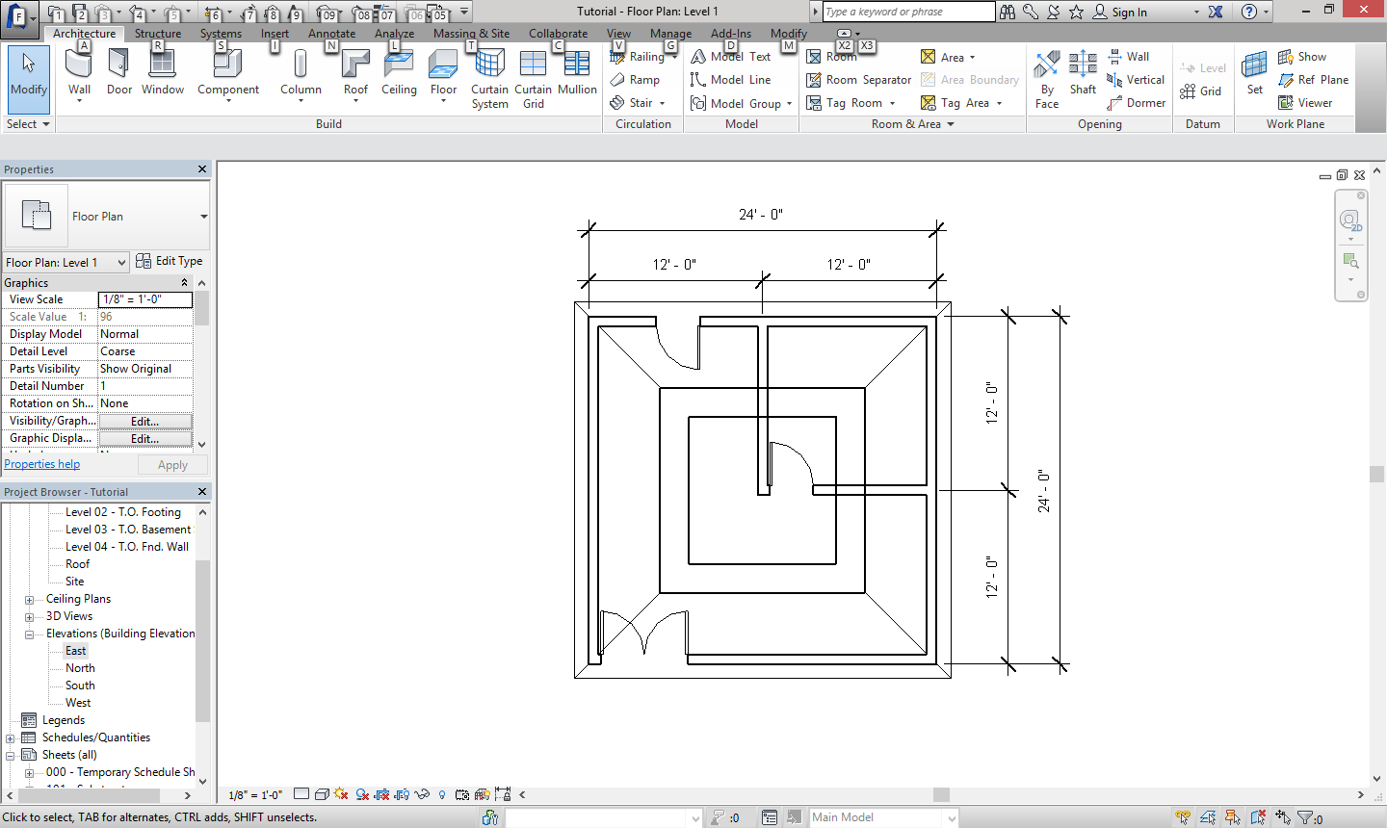

If your roof appears like this one, then we need to adjust the level the roof is on.

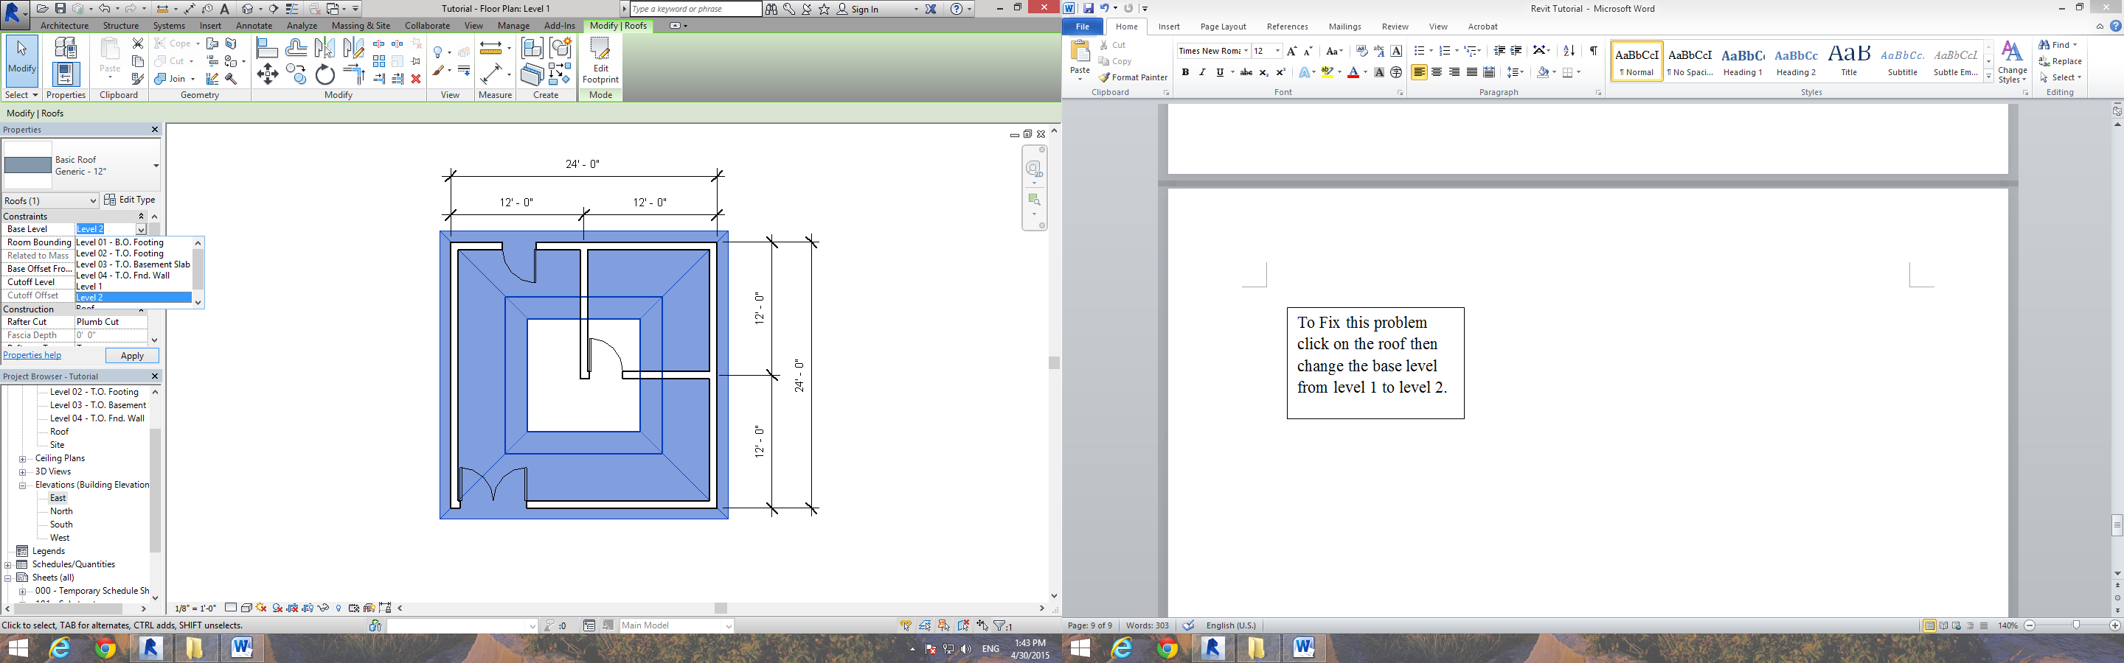

Gable Roof

To Fix this problem click on the roof then change the base level from level 1 to Roof

The next roof we are going to make is the Gable roof. You sill select roof by footprint but only the left and right walls have a defined slope. We still want a 1’ overhang.

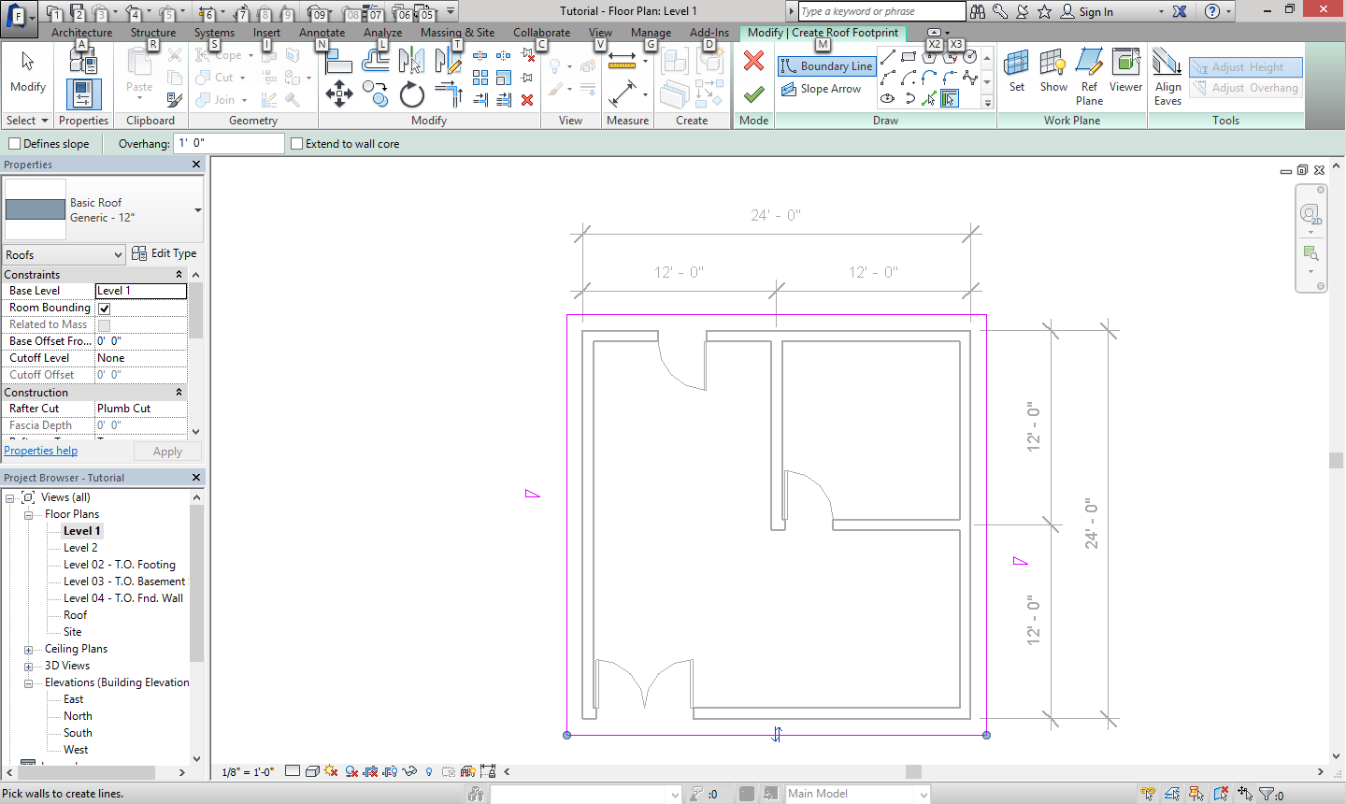

The Triangles highlighted mean that the wall nearby has a defined slope.

To get rid of the triangles, get the modify tool and select the line, then in the top green bar, unselect “Define Slope”

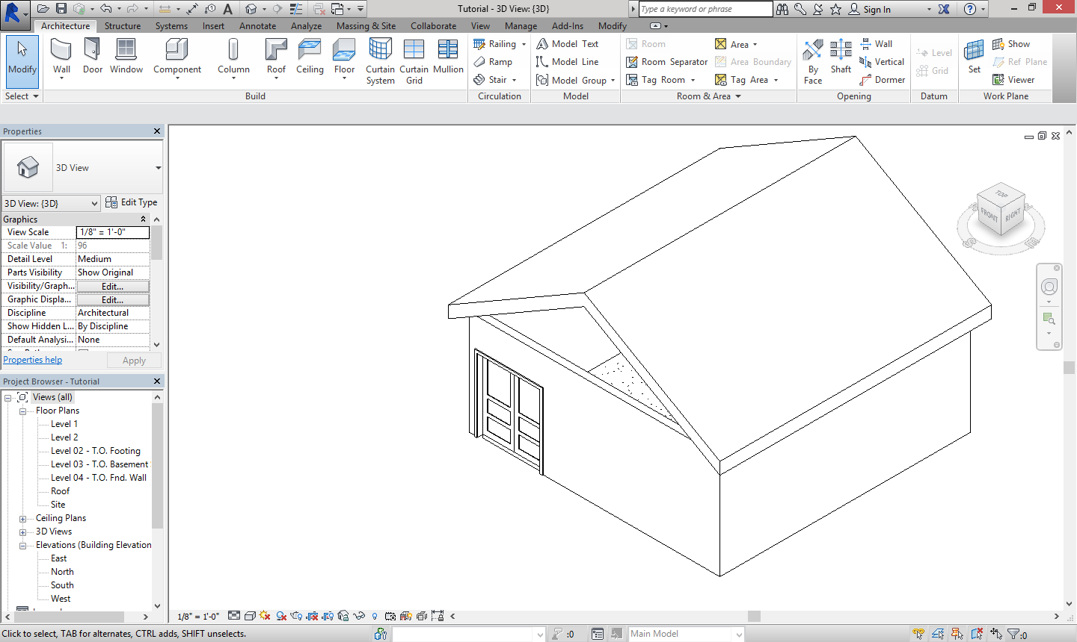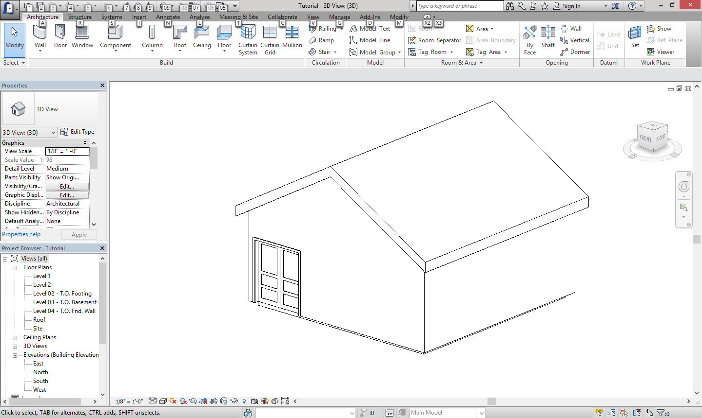

Hint: To get to the 3D views go to the view tab then click 3D View.

To get out of the 3D view, on the left hand side of the screen there is a Project Browser. Here double click level 1 to exit.

As you will notice, the roof is not connected to the walls. To connect them select the wall, then click Attach Top/Base and then click on the roof.

Hint: Don’t forget the interior walls. To get the orbit wheel press Shift W. You can then see into the house through the gap between the roof and exterior walls.

Single Slope

This roof has only one slope. (Hints the name). Again we want a roof by footprint, but we only want one of the walls to have a defined slope like shown.

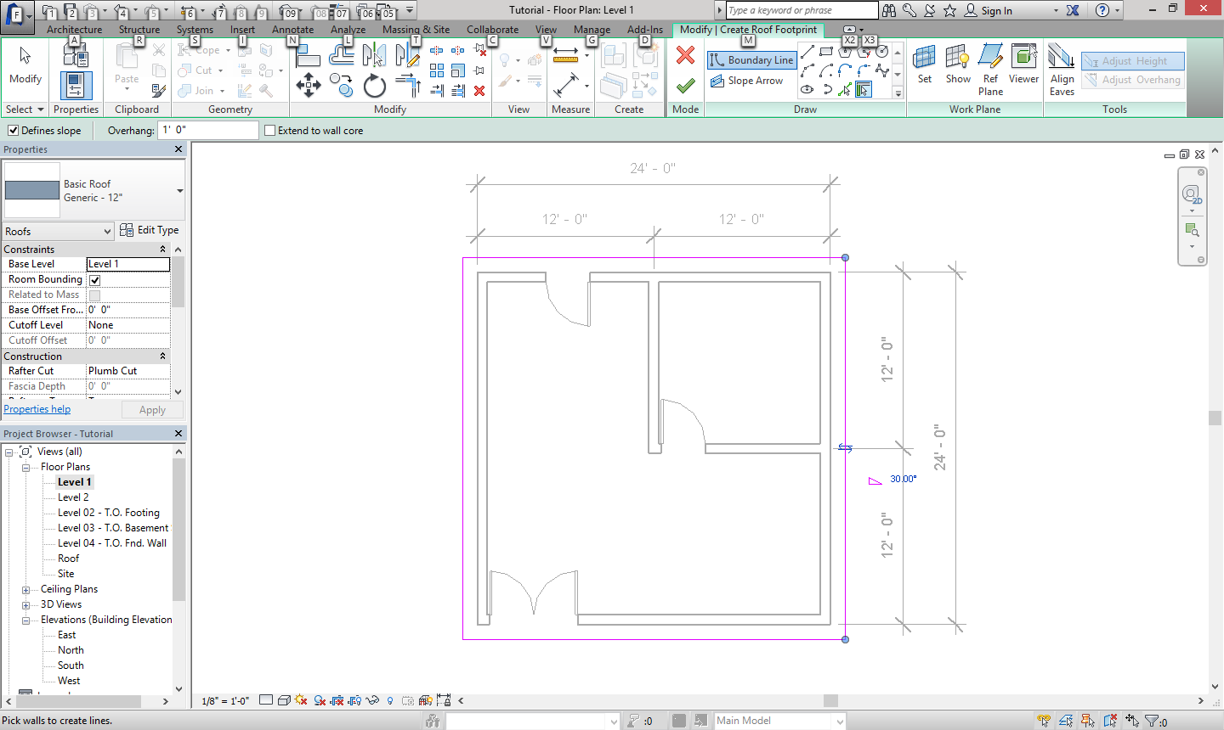

We also still have to “attach top/base”.

When Finish it should look like below.

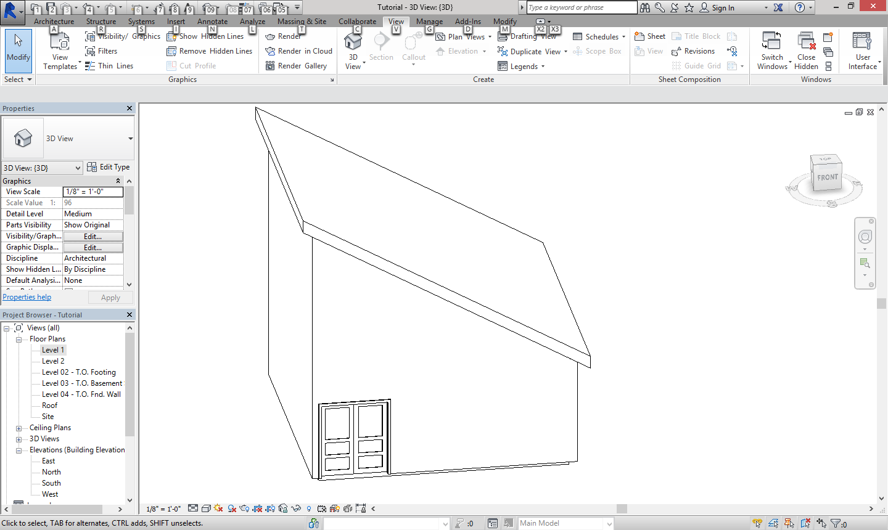

Now we are going to add windows, but first we need to load them. Go to window then select load family. Then click on the windows folder and select the one you want. In this case I’m going to choose the Archtop with Trim. For the front window we want the size to be 72”x48”. For all the others we want 30”x60”. Arrange the windows like shown below.

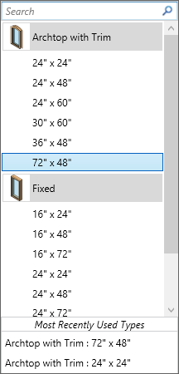 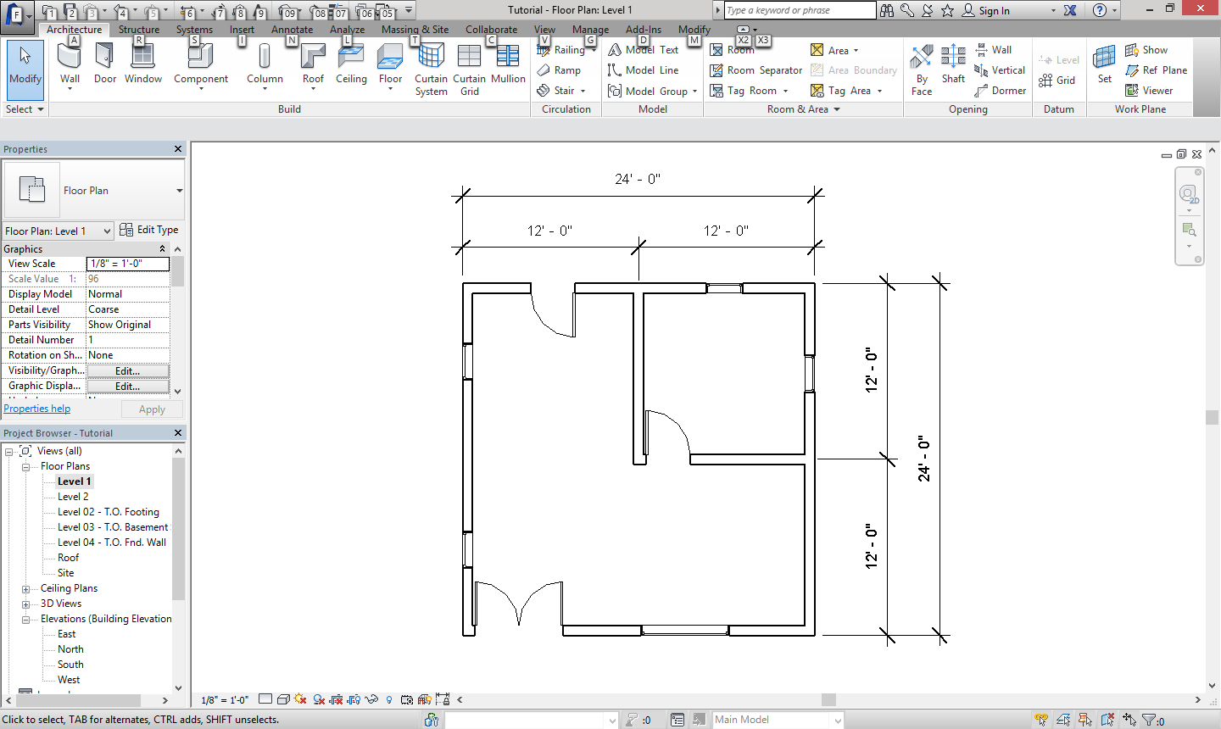

Next we are going to add a foundation with a footing. To do this we need to go to wall and select structural. We want the kind of wall to be a basic wall foundation- 12” concrete. We also want the offset to be 9”. You will need to select the pick lines tool for this job. Hover over the outside of the wall, so that the blue dotted line is toward the inside of the house.

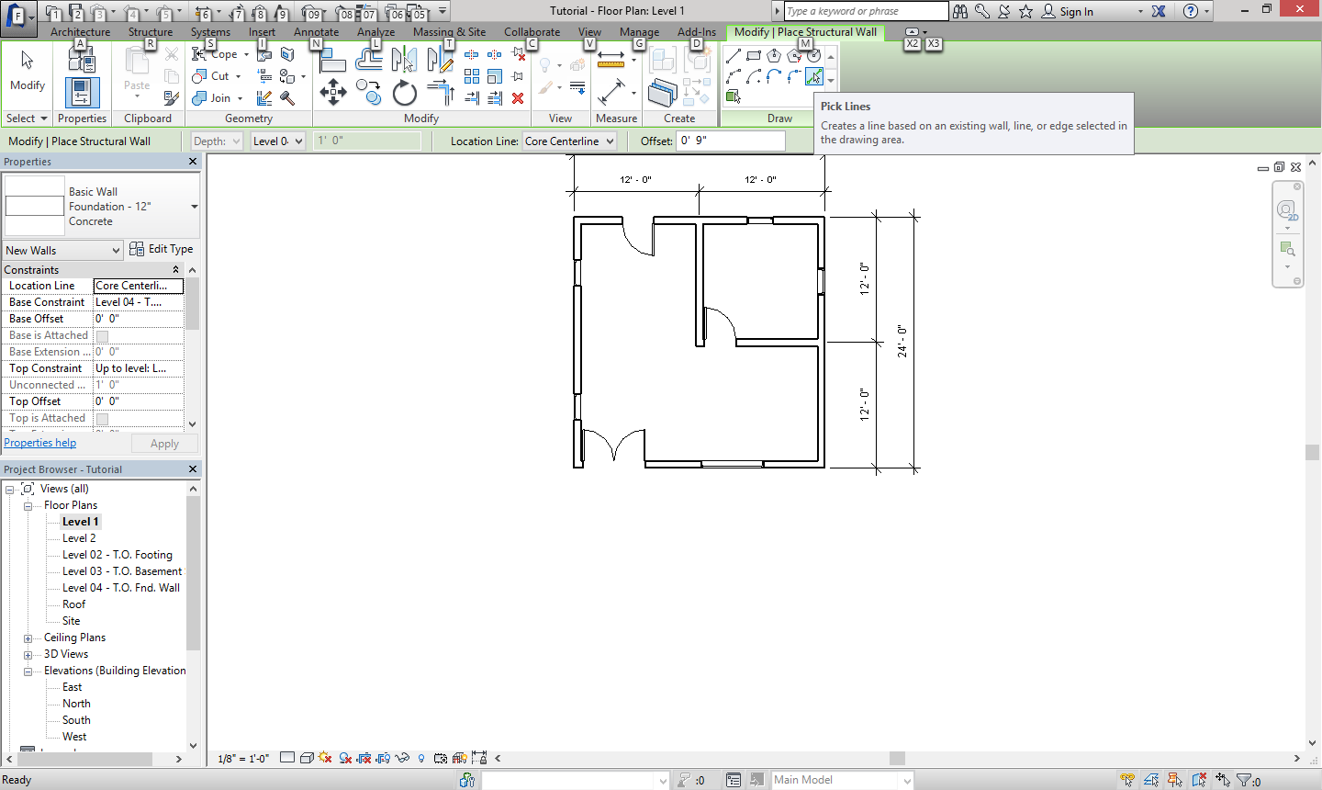

You want to make the walls like shown in the picture bellow. You also want the Base Constraint to be Foundation

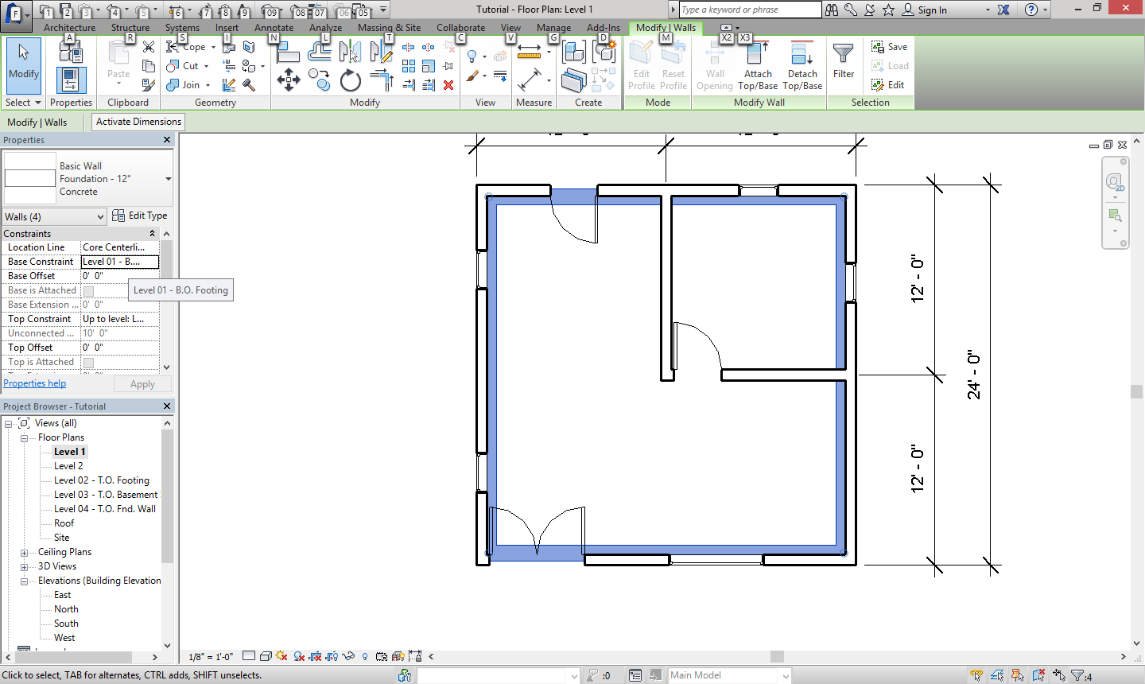

In the 3D view (which you get to by going “view” then “3D view”) your house should look like the one bellow. Now we need to add the footing. To do this, go to structure then the second wall

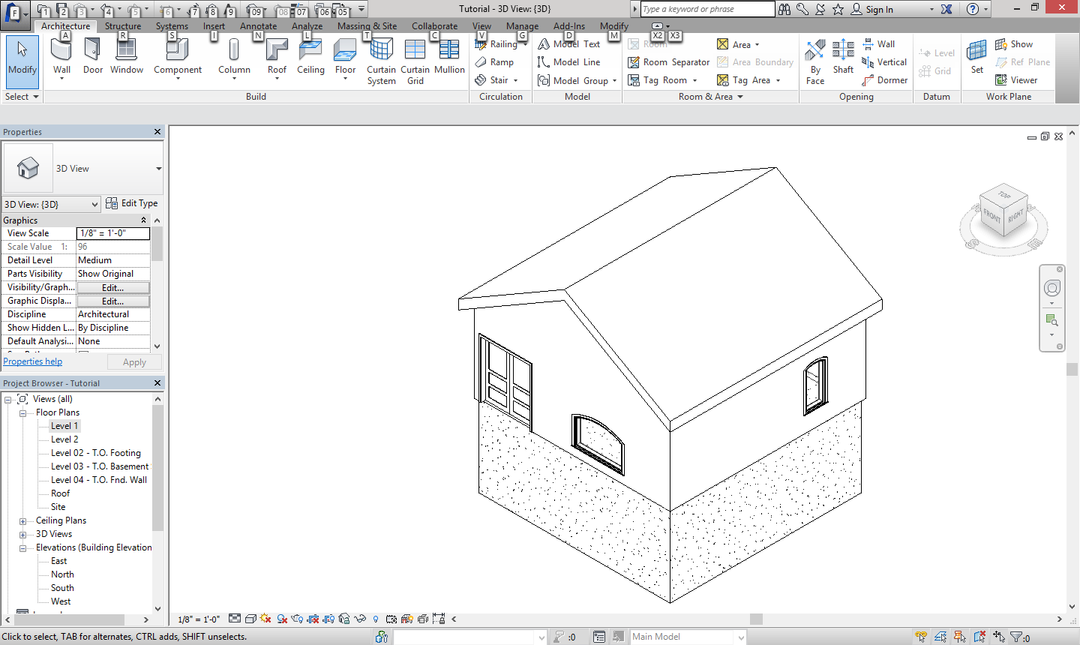 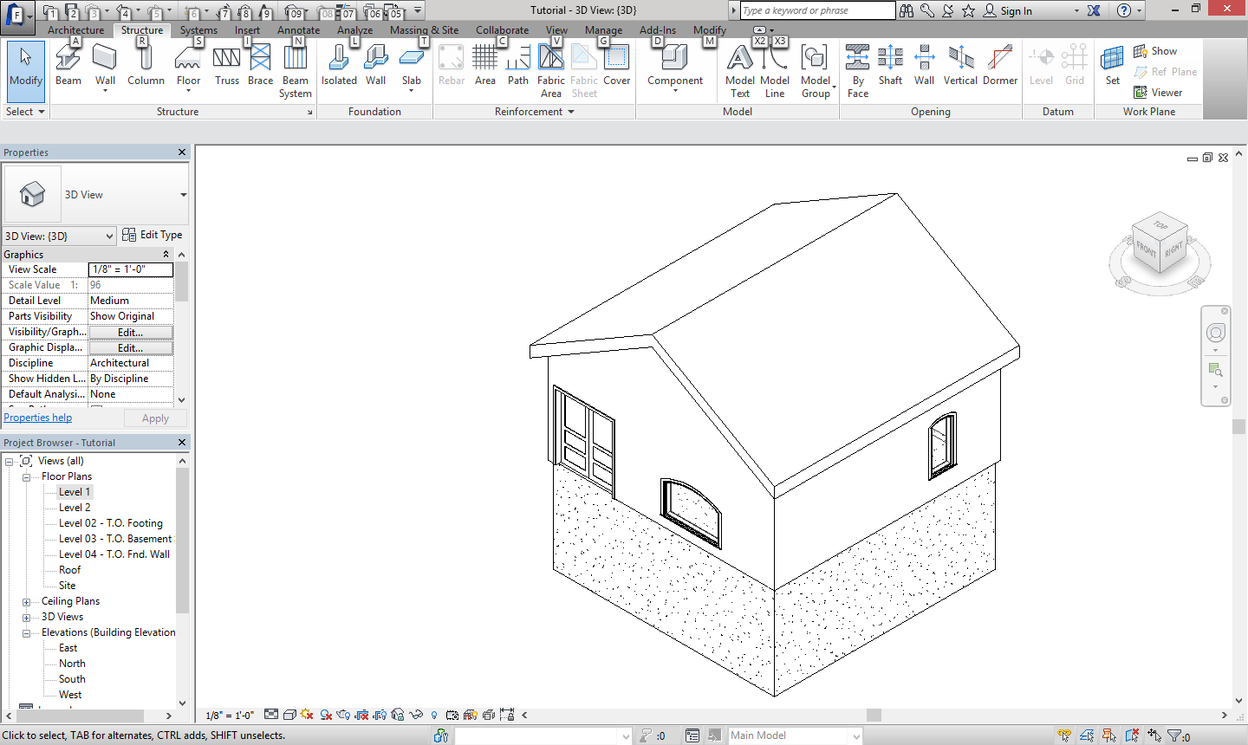

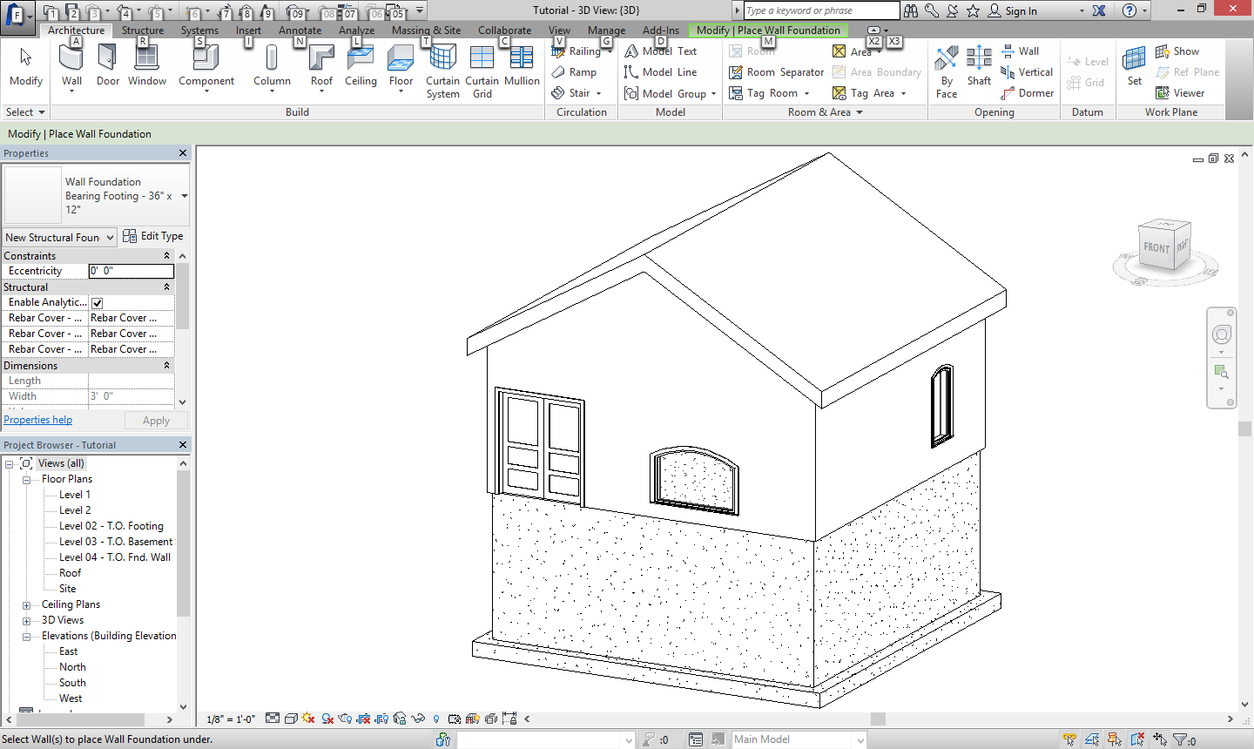

This is what the finished product should look like.

Next is the interior design. If you click on component then load family, you can place almost anything. I created the layout below.

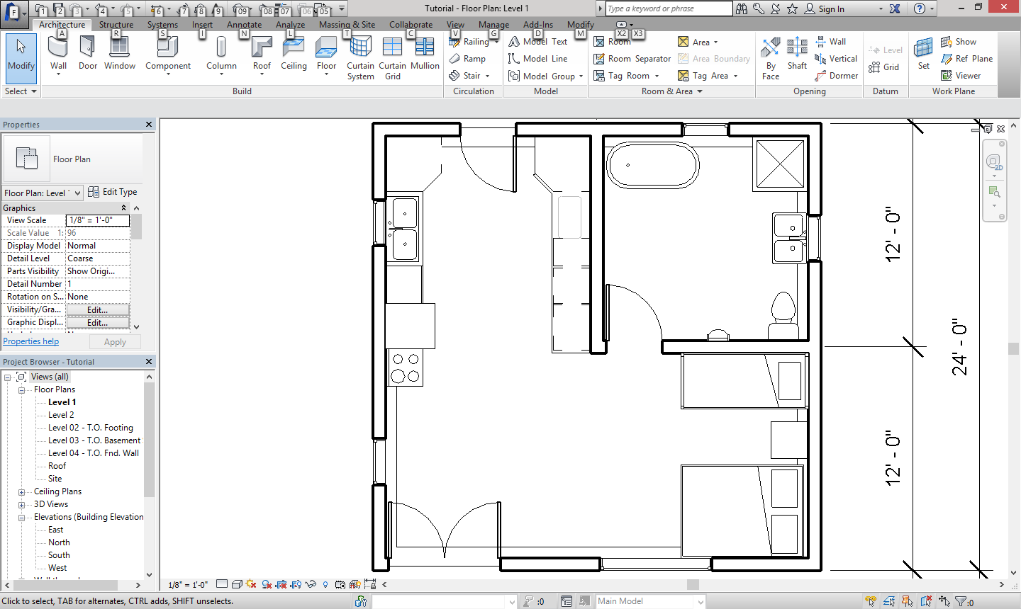

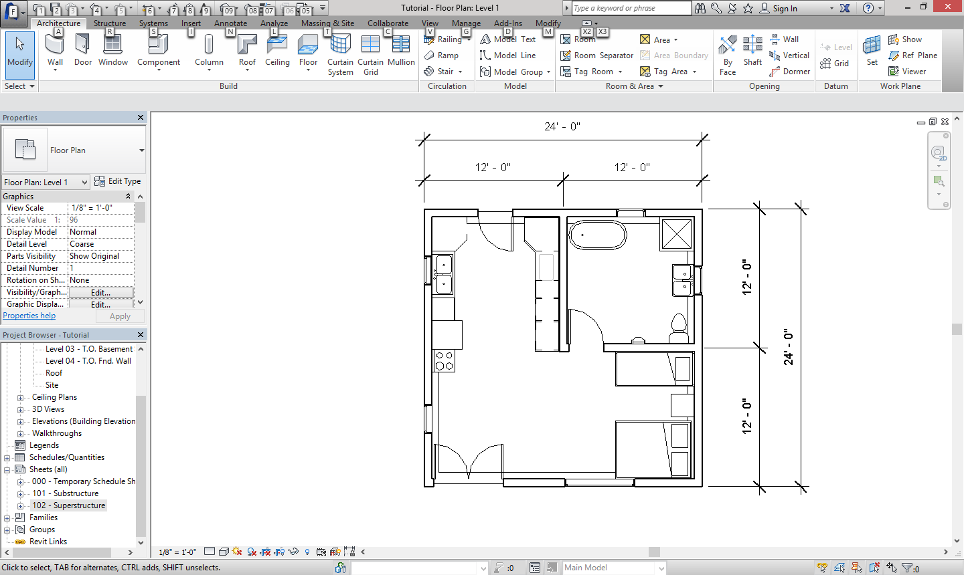

To make a new sheet, right click on Sheets (all) then select New Sheet. You then want to load a sheet, click load then scroll all the way down to Titleblocks. And we want the A size sheet. Click Ok when done.

Last we need to do some drawings. In the project tab there is a dropdown menu that says “sheets (all)”. In this folder you want to delete all the default sheets so we can make our own.

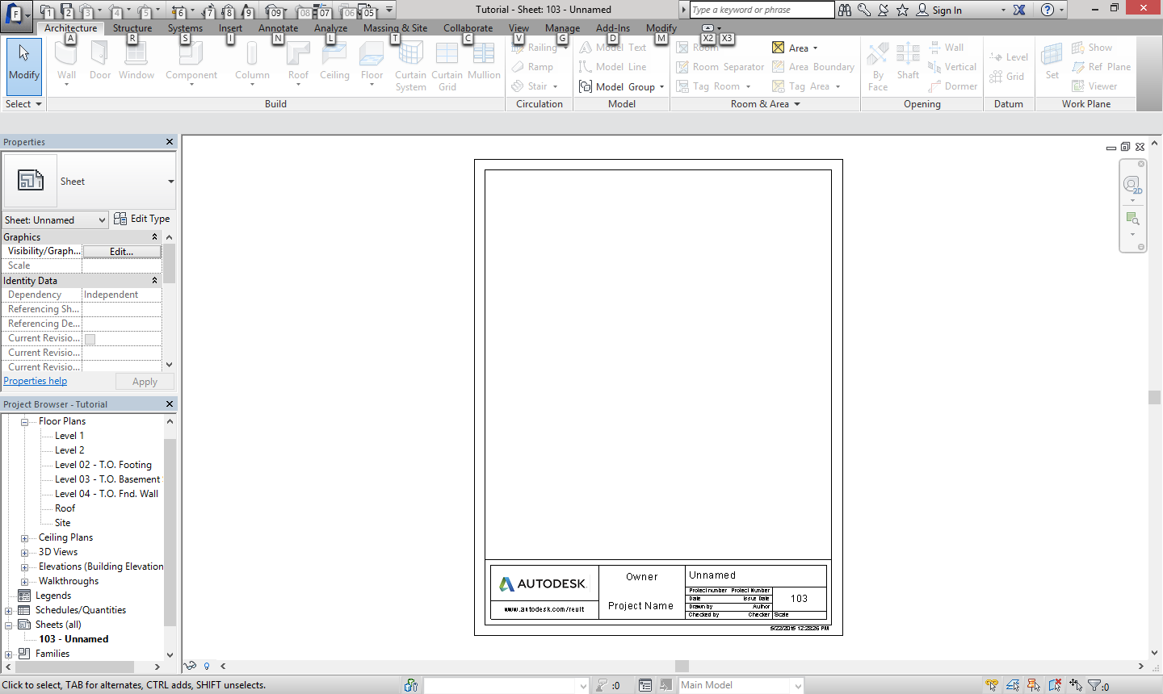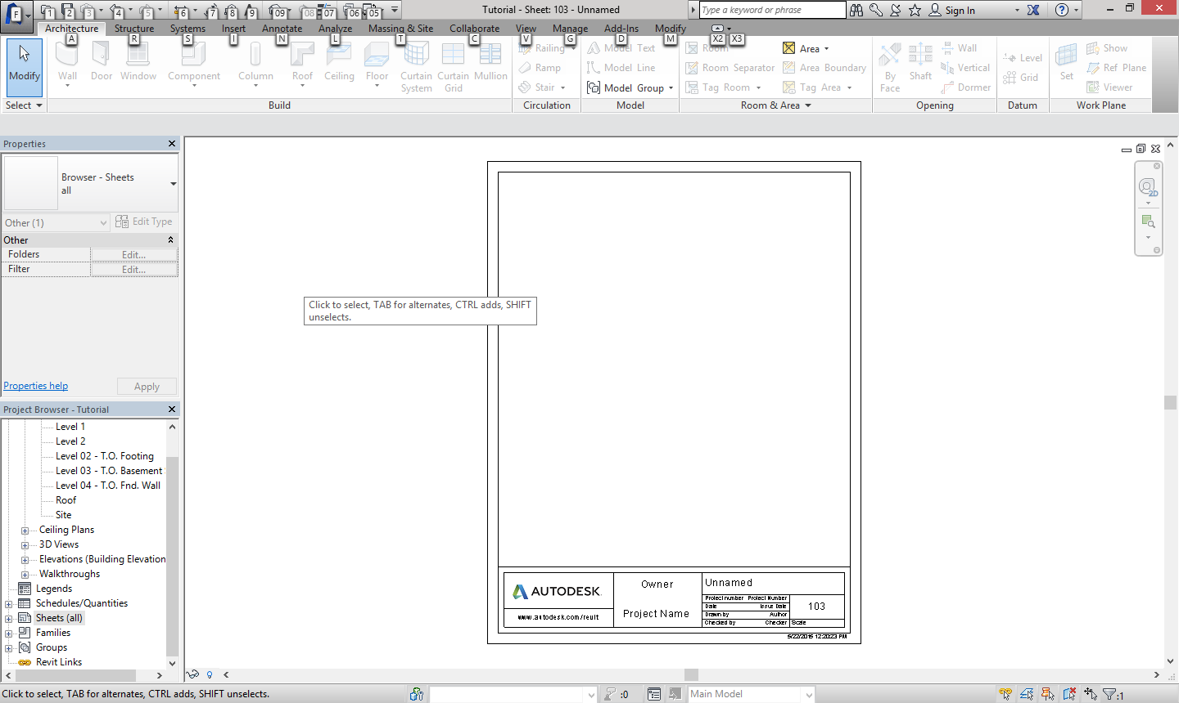

The sheet bellow will pop up. In the Project Browser tab we want to drag the level 1 floor plan to the new sheet we just made.

If you click anywhere the floor plan will appear. You can drag the floor plan on to the sheet and adjust the scale in the properties tab. I went with a scale of 3/16” = 1’-0” the end product should look like bellow.

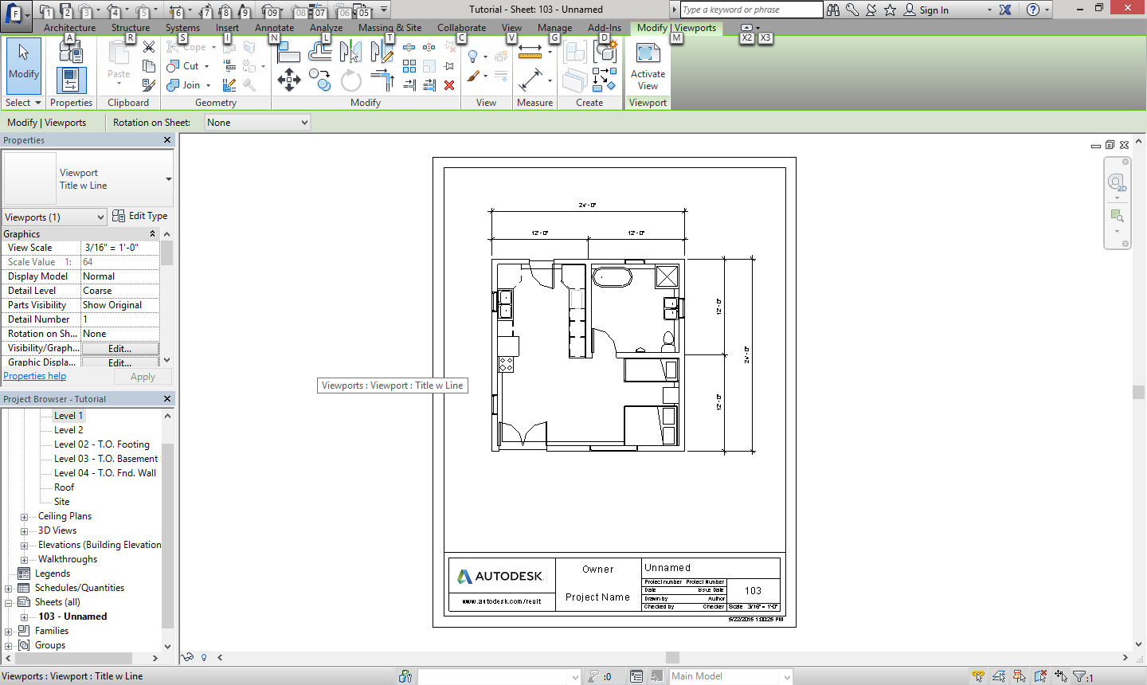

You can repeat this process to create other drawing like elevations or 3D views.

We are going to make a North Elevation. Make a new sheet like before but this time the A size sheet is already loaded for us.

You can change the information at the bottom by hovering over the box you want to change then select it.

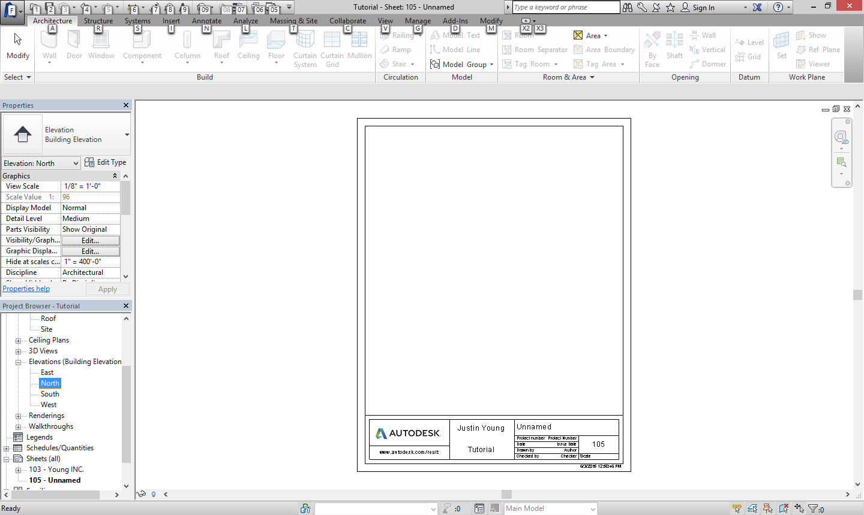

We still want to drag the North elevation to our new sheet.

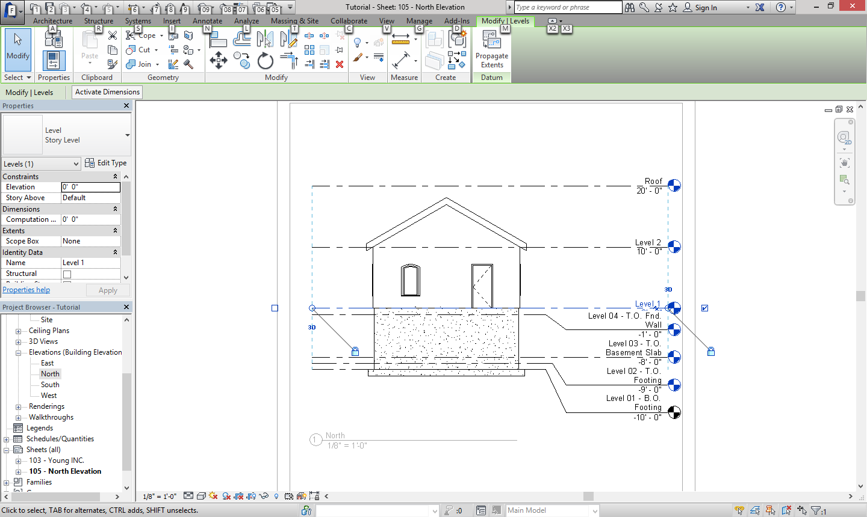

When you initially open the elevation, the scale is correct but the elevation doesn’t fit on the sheet. When you select the line or title a little dot appears that you can drag to fit the sheet.

Next is the rendering. Go to view then render, but make sure you are in the 3D view first. You then want to change the quality to Medium; I went with an exterior lighting of Sun and Artificial; and I changed the background color to light blue.

Next is to click render and “save to project”.

Finished Product is like bellow.

